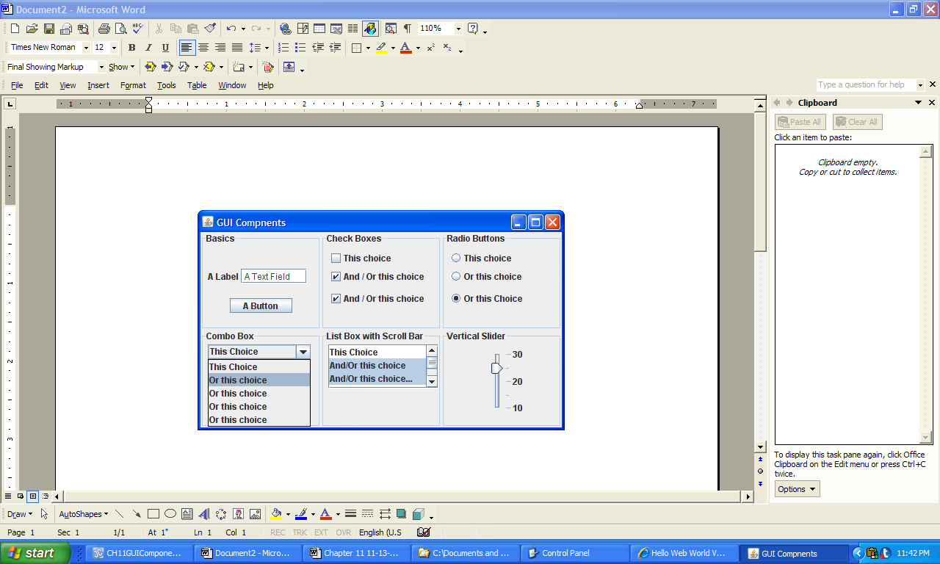

**Figure 11.1 Commonly used Graphical User Interface components.**